



PROJECT REPORT

DATA ANALYTICS  
  
RESUME ANALYTICS

|  |  |  |  |
| --- | --- | --- | --- |
| **Created By:** | Harshita Kilari | **Approved By:** | Harshadha Topale |
| **Created On:** | 25-09-2023 | **Approved On:** | DD-MMM-YYYY |

Page left blank intentionally

**INDEX**

**1** **PROJECT DETAILS** 2

**2** **SUMMARY** 2

**3** **INTRODUCTION** 2

3.1 Background 2

3.2 Stakeholders 2

3.3 Objectives 2

**4** **METHODOLOGY** 2

4.1 Considerations & Assumption 3

4.2 Approach 3

4.3 Activities 3

**5** **TARGETTED V/S ACHIEVED OUTPUT** 3

**6** **CONCLUSION** 3

**7** **APPENDICES** 4

7.1 Appendix A – Title 4

# **PROJECT DETAILS**

|  |  |  |  |
| --- | --- | --- | --- |
| **Project Name** | Resume Analytics | | |
| **Project Sponsor** | Tushar Topale | | |
| **Project Manager** | Harshadha Topale | | |
| **Start Date** | 01-08-2023 | **Completion Date** | 28-09-2023 |

# **SUMMARY**

This project tackled the high rejection rate of resumes during initial screening in a fiercely competitive job market. With a focus on job seekers, recruiters, educational institutions, and career counsellors, it aimed to provide data-driven solutions. The objectives included conducting in-depth analyses of student intern success factors, optimizing resumes, and reducing rejection rates. Using a structured approach involving data cleaning and visualization, the project successfully met its goals. The findings empower stakeholders to make informed decisions, improve career development, and enhance competitiveness. Future endeavours may involve predictive models and industry benchmarking. In conclusion, this project delivers valuable insights that benefit both job seekers and recruiters, improving talent management and career prospects.

# **INTRODUCTION**

## Background

In the contemporary job market, millions of students and professionals actively seek internships and job opportunities annually. The resume, a concise document summarizing one’s qualifications and experiences, assumes a pivotal role as the first point of contact between job seekers and potential employers. However, an alarming reality prevails recruiters dedicate a mere 2-3 minutes to review each resume that enters their mailbox, job board, or Applicant Tracking System (ATS). Astonishingly 70% of these resumes face rejection during this initial screening phase.

This rejection rate underscores the critical importance of meticulously crafting a compelling resume. In an increasingly competitive job landscape, job seekers must seekers must devote considerable effort and attention to detail when preparing their resumes. A high- quality resume not only serves as a passport to employment but also as a tool for navigating the intricate hiring processes employed by organizations today.

## Stakeholders

**Job Seekers (Students and Professionals):** The primary beneficiaries, seeking assistance in improving their resumes and increasing their chances of success in job applications.

**Recruiters and Employers:** The project indirectly benefits recruiters by reducing the number of underqualified resumes, enabling them to focus on higher- quality candidates.

**Educational Institutions:** Universities and colleges can use insights from this project to enhance career development programs for their students.

**Career Counsellors:** Professionals responsible for guiding students and job seekers in resume preparation and job application strategies.

**Project Team:** Developers, data analysts, and data scientists involved in creating and maintaining the resume optimization system.

## Objectives

The primary objectives of this project, as outlined in the Project Charter, are to:

1. Conduct a comprehensive analysis of student interns to gain insights into the relationship between academic performance, event participation, career aspirations, and factors influencing success.
2. Develop a data-driven system that optimizes, improving the likelihood of passing initial screening processes.
3. Provide job seekers with personalizes recommendations to enhance their resumes based on data-driven insights.
4. Reduce the rejection rate of resumes during initial screenings by a significant percentage.
5. Enhance the competitiveness of job seekers in a competitive job market.
6. Facilitate better career development and employment opportunities for students and professionals.

The Objectives align with departmental goals and address the need for an automated solution to the resume optimization process, which is currently performed manually. The project interfaces with existing educational and career development systems, contributing valuable insights for better decision- making. It aims to solve the problem of high resume rejection rates and manual resume preparation processes. The success of the project relies on the corporation of the key stakeholders and a dedicated project team with the necessary expertise and resources.

# **METHODOLOGY**

These conventions are all about the positions of line breaks, how many characters should go on a line, and everything in between.

## Considerations & Assumption

In the process of delivering this project, several critical considerations and assumptions were made to ensure its successful execution. These factors guided our decision- making and approach:

**Assumptions:** One fundamental assumption was made regarding the “Designation” column in the dataset. We assumed that all entries in this column corresponded to students or interns. This assumption allowed us to filter and analyse the data more effectively for student- centric insights.

Other assumption was made

**Constraints:** Fortunately, this project did not encounter any significant constraints that could impede its progress or completion. We had the flexibility to proceed with the data analysis and visualisation tasks without any major limitations.

**Risks:** A key risk identified during the project was related to data cleaning. It was crucial to ensure that the data cleaning process was executes correctly. For instance, we had to convert the “Family income” column from text to numeric format. Any errors in data cleaning could lead to incorrect results and negatively impact the project’s outcomes.

## Approach

The approach adopted for this project was structured to address the specific problem at hand and leverage the available tools and data. The primary reasons for this approach were as follows:

Our structured approach involved the following key steps:

**Data Cleaning with Excel:** I initiated the project by using Microsoft Excel for data cleaning. This step was critical to ensure data accuracy and consistency. Cleaning tasks included handling text-to-number conversions, removing duplicates, and standardizing data formats.

**Data Modelling and Visualization with Power BI:** After data cleaning, we utilized Power BI as our primary data modelling and visualization tool. Power BI enabled us to create meaningful visualizations, generate insights, and build interactive reports. We leveraged DAX functions to create measures that helped answer specific project questions.

## Activities

The project encompassed a series of activities aimed at delivering meaningful insights from the dataset. These activities were carried out systematically and included the following key tasks:

* **Requirement Gathering:** We started by defining the project's scope and gathering requirements, including the list of questions to be answered using the dataset.
* **Data Cleaning:** The data cleaning process was a critical activity. It involved standardizing data formats, addressing missing values, and ensuring data accuracy.
* **Data Modelling:** Using Power BI, we created data models to structure the dataset for analysis. This step involved defining relationships between tables and creating calculated columns and measures.
* **Data Visualization:** We used Power BI's visualization capabilities to create interactive charts and dashboards that provided insights into the dataset.
* **Answering Project Questions**: We systematically addressed each of the project questions using the data and visualizations created in Power BI.
* **Project Documentation:** Documentation was a crucial aspect, and it included creating a Project Charter, Software Requirement Specification (SRS), Work Breakdown Structure (WBS), Project Plan, RAID (Risks, Assumptions, Issues, Dependencies) logs, Lessons Learned Log, and a comprehensive Project Report.
* **Final Deliverables:** The project's final deliverables included the Power BI file (.pbix) containing all visualizations and calculations, along with the various project documentation mentioned above.

# **TARGETTED V/S ACHIEVED OUTPUT**

The Target output were as follows: To conduct a comprehensive analysis of our student interns to gain insights into the relationship between their academic performance, event participation, career aspirations, and factors influencing their success, and to utilize the collected dataset containing various attributes for each student to achieve the objectives of this analysis.

We successfully conducted a comprehensive analysis of student interns based on the provided dataset. Our analysis encompassed a wide range of aspects, including academic performance, event participation, career aspirations, and various influencing factors. The achieved results have provided valuable insights into the dynamics of student success in our organization, and the dataset provided was effectively utilized throughout the project. We employed Excel for data cleaning and Power BI for data modelling and visualization, which allowed us to extract meaningful insights. DAX functions were used to create measures and visualizations, enabling us to answer specific questions and address the project's objectives.

But the **Deviation:** The project timeline extended by a few days beyond the initial estimate.

**Reason for Deviation:** The data cleaning process proved to be more time-consuming than initially anticipated due to the intricacies involved in standardizing data formats and ensuring accuracy. This led to a slight extension of the project timeline. However, this deviation did not impact the overall success of the project. And also the personal laptop in which I was performing the data analysis is damaged where the repair made the closure of the project delayed.

# **CONCLUSION**

The successful completion of this project marks a significant milestone in our quest to gain deeper insights into the factors influencing the success of our student interns. By conducting a comprehensive analysis of the provided dataset, we have not only achieved our project objectives but also laid the foundation for data-driven decision-making that will benefit our organization and stakeholders in various ways.

**Benefits for Stakeholders:**

The insights generated from this project hold substantial value for our stakeholders, including HR teams, recruiters, and management. Here's how the findings will prove useful:

1. Informed Recruitment Decisions: Recruiters can make more informed decisions during the initial screening process by considering factors such as academic performance, event participation, and career aspirations. This will improve the efficiency of the recruitment process and increase the chances of selecting the right candidates.

2. Tailored Career Development: HR teams can use the insights to tailor career development programs and opportunities for student interns. Understanding the relationship between academic performance and career aspirations can help create personalized growth paths.

3. Predictive Analytics: With the foundation of this analysis, future projects can explore predictive analytics to forecast the success of student interns based on their profiles. This can further enhance recruitment strategies.

**Future Scope:**

While this project has provided valuable insights, there are several avenues for future exploration and improvement:

1. Predictive Models: Building predictive models to forecast the success of student interns can be the next step. Machine learning algorithms can be employed to analyse historical data and predict future performance.

2. Comparative Analysis: Comparing our organization's data with industry benchmarks can provide a broader perspective on intern performance and success.

In **conclusion**, this project has successfully achieved its objectives by providing valuable insights into the factors influencing the success of student interns. These insights will empower our organization to make data-driven decisions, improve recruitment processes, and enhance the overall experience of student interns.

# **APPENDICES**

## Appendix A – Title

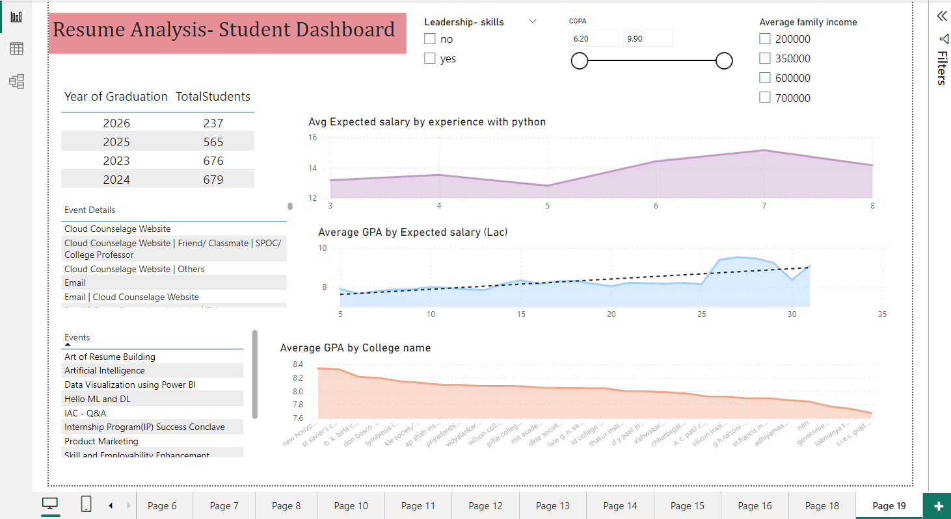

The is the final visualising dashboard I have created.